**Fintech AI Research Project 2**

**The Efficient Frontier: Markowitz portfolio optimization in Python and TensorFlow**

Harry Max Markowitz (born August 24, 1927) is an American economist, and a recipient of the 1989 John von Neumann Theory Prize and the 1990 Nobel Memorial Prize in Economic Sciences.

Markowitz is a professor of finance at the Rady School of Management at the University of California, San Diego (UCSD). He is best known for his pioneering work in modern portfolio theory, studying the effects of asset risk, return, correlation and diversification on probable investment portfolio returns.

Markowitz now divides his time between teaching (he is an adjunct professor at the Rady School of Management at the University of California at San Diego, UCSD); video casting lectures; and consulting (out of his Harry Markowitz Company offices).

Markowitz’s more recent work has included designing the backbone software analytics for the GuidedChoice investment solution and heading the GuidedChoice Investment Committee.

**His Research**

Modern Portfolio Theory (MPT), a hypothesis put forth by Harry Markowitz in his paper "Portfolio Selection," (published in 1952 by the Journal of Finance) is an investment theory based on the idea that risk-averse investors can construct portfolios to optimize or maximize expected return based on a given level of market risk, emphasizing that risk is an inherent part of higher reward. It is one of the most important and influential economic theories dealing with finance and investment.

Also called "portfolio theory" or "portfolio management theory," MPT suggests that it is possible to construct an "efficient frontier" of optimal portfolios, offering the maximum possible expected return for a given level of risk. It suggests that it is not enough to look at the expected risk and return of one particular stock. By investing in more than one stock, an investor can reap the benefits of diversification, particularly a reduction in the riskiness of the portfolio. MPT quantifies the benefits of diversification, also known as not putting all of your eggs in one basket.

Read more: Modern Portfolio Theory (MPT) <https://www.investopedia.com/walkthrough/fund-guide/introduction/1/modern-portfolio-theory-mpt.aspx#ixzz56p723VDD>

**Background**

Modern portfolio theory aims at investing one’s wealth in various securities selected carefully in proper proportions to maximize the portfolio’s expected return for a given portfolio risk, or equivalently minimize risk for a given level of expected return.

A collection of such securities is referred to as a diversified portfolio of investments. The portfolio performance is measured in terms of its realized return and variance. The expected return is interpreted as the reward of the investment and variance as its risk.

**Assumptions**

All the portfolio components are considered risky.

There is no short selling - ensures positive weights.

There is no transaction costs or brokerage fees.

**The Problem**

Consider a portfolio of financial securities, characterized by their expected mean and covariances. The idea is to find the optimal weight w of each security such that the overall portfolio provides the smallest risk for a given overall return.

In other words, the problem is to find the ‘efficient frontier’ or the set of all achievable portfolios that offer the highest rate of return for a given level of risk.

Some Notation

We shall denote by

w – the vertical vector of weights of the different securities in the portfolio

R – the vertical vector of individual expected returns of the securities.

V – the matrix of variance-covariances between securities.

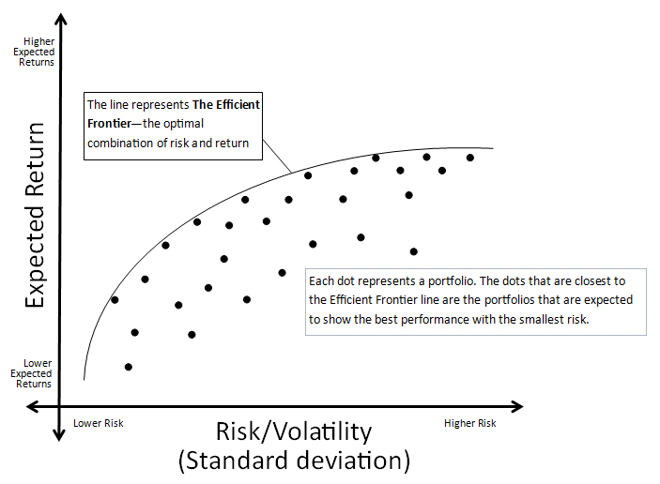

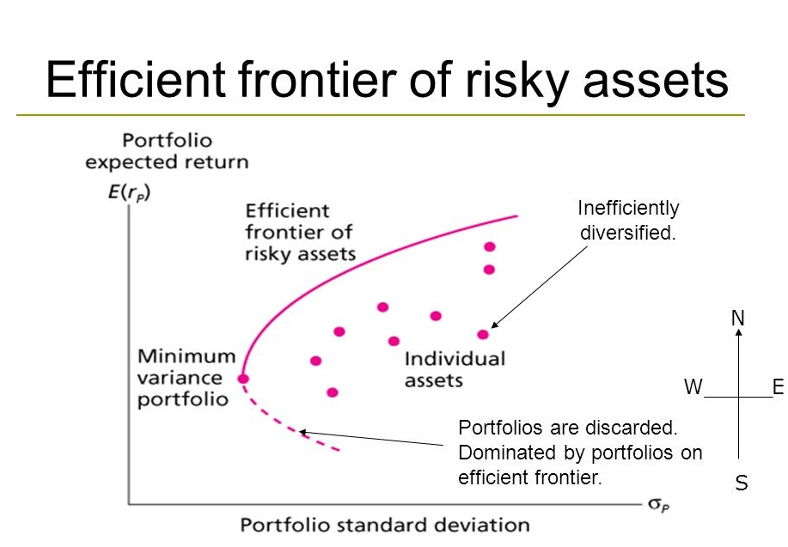

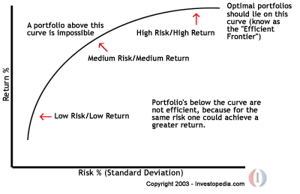

**Step One: Basic Data Science Code**

Understand and run this basic code from the following two articles:

<http://dacatay.com/data-science/portfolio-optimization-python/>

<http://www.pythonforfinance.net/2017/01/21/investment-portfolio-optimisation-with-python/>

**Step Two: Understand and Run Intermediate Python Code both Part 1 and Part 2**

Please read the articles, understand and run the code:

<https://medium.com/python-data/effient-frontier-in-python-34b0c3043314>

<https://medium.com/python-data/efficient-frontier-portfolio-optimization-with-python-part-2-2-2fe23413ad94>

**Step Three: Understand and Run Advanced Python Code**

Please read the article, understand and run the code:

<https://blog.quantopian.com/markowitz-portfolio-optimization-2/>

**Step Four: Markowitz Efficient Frontier using Kaggle Data using Python**

Using the knowledge you gained in the above three steps, use the data from this Kaggle dataset and calculate and plot the efficient frontier in Python:

<https://www.kaggle.com/gerardoluisalcala/markowitz-efficient-frontier/>

**Step Five: Markowitz Efficient Frontier using Crypto Data using Python**

Now using the live crypto historic price data for the 30 crypto’s included in the Crypto 30 index ( <https://www.crypto30.com/index/> ) calculate and plot the efficient frontier using Python.

Note: Also draw the Capital Market Line (Please check step 7 link for details).

**Step Six:** **Markowitz Efficient Frontier using Crypto Data using Python Library**

Use the following library to recreate the functionality of step five.

<https://github.com/czielinski/portfolioopt>

**Step Seven:** **Markowitz Efficient Frontier using Crypto Data using Second Python Library**

Use the following library to recreate the functionality of step five.

<http://dx-analytics.com/11_dx_mean_variance_portfolio.html>

Note: Also draw the Capital Market Line using this library, and in step 5 without the use of this Library.

**Step Eight: Markowitz Efficient Frontier using Crypto Data using TensorFlow**

Now using the live crypto historic price data for the crypto’s included in the Crypto 30 index ( <https://www.crypto30.com/index/> ) calculate and plot the efficient frontier using TensorFlow.

**Learning Resources:**

<https://stackoverflow.com/questions/48289257/tensorflow-add-variables-weights-constraint>

<https://github.com/rmonajemy/Portfolio-of-Tensorflow-code/blob/master/Edge_Detector_using_TensorFlow.py>

<https://github.com/chaitjo/markowitz-portfolio-optimization>

<https://github.com/kvathupo/qfs-optimization>

<https://github.com/cpcdoy/Portfolio-Manager>

<https://github.com/ferreirafabio/cram1>

Machine Learning in Finance:

<https://www.techemergence.com/machine-learning-in-finance/>

We can join it if we become experts:

<https://www.quantopian.com/>

Check this guy, he has this project on his resume ☺

<https://chaitjo.github.io/assets/Chaitanya_Joshi_Resume.pdf>

Experienced Developers Please Review:

Review the Presentation:

<https://www.researchgate.net/publication/316037377_Markowitz_and_Kelly_Portfolio_Theories_in_iPython>

Download:

<https://www.researchgate.net/profile/Michael_Kateregga2/publication/316037377_Markowitz_and_Kelly_Portfolio_Theories_in_iPython/links/58edf922aca2724f0a285ce5/Markowitz-and-Kelly-Portfolio-Theories-in-iPython.pdf>

Note: Beginners just follow the Slide 14, 15, 16